Kast Orthodontics Photos for Virtual Appointment
We are always working on ways to communicate and support our patients The purpose of this instruction guide is to help you create photos that will help us visualize the current bite. These photos will allow us to create a “Virtual Appointment.”. Information can be sent via text messages or via e-mail.
Step 1 Lighting is a key to great photos. Outdoor natural light, bright lights, flashlights and camera flashes can be very helpful. Our goal is to minimize shadows. Photos without the flash can sometimes be better than photos with the flash.
Step 2 Retraction of the cheeks and lips will be important. Retractors from games like “Speak out,” large spoons or the patients own fingers can be used. The goal is to allow more light to get less shadows

Step 3 Six Photos will give us good information to evaluate your mouth. Here are illustrations of the photos we are looking for and helpful insight for each.

Photo 1 Patient
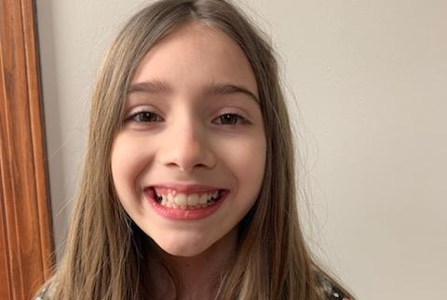
This photo is mainly for identification purposes

Photo 4 Right Bite
Make certain patient is biting on back teeth. Relax your cheeks. Make certain you get the back teeth

Photo 2 Upper Teeth
Open as wide as possible. Get top view of the teeth all the way to back teeth
Photo 5 Front Bite
Make certain patient is biting on back teeth. Relax your cheeks. Make certain you get the back teeth
Photo 3 Lower Bite
Open as wide as possible. Get top view of the teeth all the way to back teeth
Photo 6 Left Bite
Make certain patient is biting on back teeth. Relax your cheeks. Make certain you get the back teeth

Step 4 Give notice to our office or Dr. Kast that you are ready to send photos and discuss treatment. This is important to avoid confusion as multiple patients may be sending photos at one time.

Step 5 Send the Information via text or email. Photos, full name of patient, name of parent and your phone number should be included with each text or each e-mail. Additional photos may be needed upon request. Texts can be sent to Dr. Kast at 440-773-9074. Emails can be sent to kastorthodontics@gmail.com

Step 6 Our Virtual Consult will come via a call from Dr. Kast or a Clinical Staff Member. After reviewing your photos and our existing treatment photos and treatment notes, we will call and discuss treatment. Please be patient as it may take longer than usual to respond.

